1. **Scaling an image to its Bigger and Smaller sizes.**

**Aim:**

The Aim is resize the image from bigger to smaller size.

**Code:**import cv2

import numpy as np

img = cv2.imread("C:\\Users\\prith\\Documents\\CV\\cvimage.jpg", cv2.IMREAD_COLOR)

img = cv2.resize(img, (600, 600))

cv2.imshow('Resized Image', img)

cv2.waitKey(0)

cv2.destroyAllWindows()

**Input:**

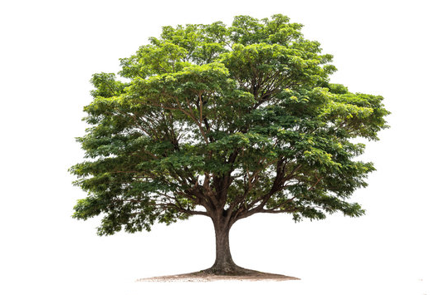

**Output:**

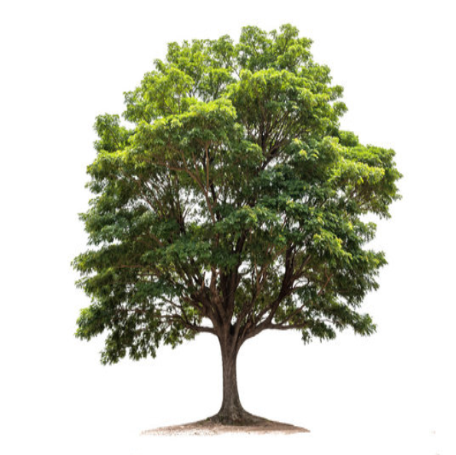

**Result:**

The python code to enlarge the picture has been successfully executed.